1. **What are the characteristic requirements for wireless sensor network.**

● **Deeply distributed architecture:** localized coordination to reach entire system goals, no infrastructure with no central control support

● **Autonomous operation:** self-organization, self-configuration, adaptation, exception-free

● TCP/IP is open, widely implemented, supports multiple physical network, relatively efficient and light weight, but requires manual intervention to configure and to use.

● **Energy conservation:** physical, MAC, link, route, application

● **Scalability:** scale with node density, number and kinds of networks

● **Data centric network:** address free route, named data, reinforcement-based adaptation, in-network data aggregation.

1. **Differentiate between active and passive sensors.**

**Active Sensors**

**Definition**: Active sensors emit their own signal or energy and measure the response or reflection of that signal from the target or environment.

**Key Characteristics**:

1. **Energy Emission**: Active sensors generate their own energy (e.g., radio waves, laser light) to illuminate the target.
2. **Self-sufficiency**: They do not rely on external sources of energy for illumination.
3. **Day/Night Operation**: They can operate during day and night since they provide their own source of illumination.
4. **Weather Independence**: Many active sensors can penetrate clouds, rain, and other atmospheric conditions, making them reliable in various weather conditions.

**Examples**:

* **Radar**: Uses radio waves to detect objects, their speed, and distance.
* **Lidar**: Uses laser pulses to measure distances and create high-resolution maps.
* **Sonar**: Uses sound waves to detect underwater objects.

**Passive Sensors**

**Definition**: Passive sensors detect and measure natural energy that is emitted or reflected by objects in the environment.

**Key Characteristics**:

1. **Energy Dependence**: Passive sensors rely on external sources of energy, primarily natural radiation such as sunlight.
2. **No Emission**: They do not emit any signal or energy themselves.
3. **Limited by Light Conditions**: Their effectiveness can be limited by the availability of natural light (e.g., they may not work well in darkness or under thick cloud cover).
4. **Sensitivity to Weather Conditions**: They may be affected by atmospheric conditions such as clouds, fog, and rain, which can interfere with the natural energy they are trying to measure.

**Examples**:

* **Photographic Cameras**: Capture visible light reflected from objects.
* **Infrared Sensors**: Detect heat emitted by objects.
* **Radiometers**: Measure the intensity of radiation (e.g., light, heat) from objects.

**Summary of Differences**

| **Feature** | **Active Sensors** | **Passive Sensors** |
| --- | --- | --- |
| Energy Source | Emit their own energy | Rely on external/natural energy |
| Operation in Dark | Yes, operate day and night | Limited, require natural light |
| Weather Impact | Often less affected by weather | Can be significantly affected by weather |
| Example Technologies | Radar, Lidar, Sonar | Photographic cameras, Infrared sensors, Radiometers |

1. **How clustering is useful in WSNs?**

• **Energy Efficiency**:

* **Reduced Communication Overhead**: Sensor nodes communicate with their cluster head rather than directly with the base station, saving energy.
* **Data Aggregation**: Cluster heads aggregate data from their member nodes, reducing the number of transmissions and conserving energy.

• **Scalability**:

* **Manageable Network Segments**: Clustering divides the network into smaller, manageable segments, making it easier to scale the network.
* **Localized Operations**: Operations such as data processing and routing can be handled within clusters, facilitating easier management of large networks.

• **Enhanced Routing Efficiency**:

* **Hierarchical Routing**: Clustering supports hierarchical routing, where cluster heads manage data transmission to the base station, optimizing routing paths.
* **Reduced Routing Complexity**: With fewer nodes involved in long-distance communication, routing becomes more efficient and less complex.

• **Load Balancing**:

* **Balanced Energy Consumption**: Rotating the role of cluster heads among nodes ensures that energy consumption is evenly distributed, preventing early depletion of any single node.
* **Prolonged Network Lifetime**: Balanced energy usage extends the overall lifetime of the network.

• **Improved Data Aggregation and Fusion**:

* **Reduced Data Redundancy**: Cluster heads aggregate and process data from their nodes, reducing redundancy and the volume of data sent to the base station.
* **Enhanced Data Quality**: Aggregated data from cluster heads is often more accurate and reliable.

• **Fault Tolerance and Robustness**:

* **Localized Fault Management**: Clusters allow for localized detection and management of node failures, improving network robustness.
* **Redundant Communication Paths**: Multiple cluster heads provide alternative communication paths, enhancing fault tolerance.

• **Reduced Latency**:

* **Localized Communication**: Most communications occur within the cluster, reducing transmission delays compared to direct communication with a distant base station.
* **Faster Data Processing**: Data processing at the cluster head level leads to quicker decision-making and response times.

• **Enhanced Security**:

* **Localized Security Protocols**: Clusters can implement localized security measures, making it easier to detect and mitigate threats.
* **Secure Data Transmission**: Cluster heads can act as gatekeepers, ensuring secure transmission of data to the base station.

1. **What is the concept of flooding mechanism?**

**Definition**: Flooding is a simple and robust mechanism where a message is sent to all nodes in the network without the need for routing tables or path discovery. Each node that receives the message retransmits it to its neighbors until the message has propagated throughout the entire network.

### Key Characteristics

1. **Broadcasting**: In flooding, a message is broadcast to all nodes within a node’s communication range. Each node then forwards the message to all its neighbors.
2. **Redundancy**: Due to the broadcast nature, flooding inherently creates multiple copies of the message, leading to redundancy. This ensures that the message reaches all nodes, even if some paths fail.
3. **No Routing Information**: Flooding does not require any prior knowledge of the network topology or the maintenance of routing tables, making it a straightforward method for message dissemination.
4. **Termination Condition**: Typically, a message contains a unique identifier (e.g., sequence number). Each node maintains a record of the messages it has received and processed to avoid processing the same message multiple times.
5. **What is data aggregation?**

Data aggregation is a process used in Wireless Sensor Networks (WSNs) and other types of networks to collect and combine data from multiple sensor nodes to reduce the amount of data transmitted to the base station or sink. This process helps in conserving energy, reducing bandwidth usage, and minimizing data redundancy.

**Group B**

* 1. **What are the challenges and the required mechanisms of a Wireless Sensor Network?**

**Challenges:**

1. **Energy Efficiency:** Sensor nodes are typically battery-powered with limited energy resources.
2. **Scalability:** WSNs may consist of hundreds or thousands of sensor nodes, and the network should efficiently scale without performance degradation.
3. **Data Aggregation:** Redundant data due to multiple nodes sensing the same phenomenon can lead to unnecessary data transmission and energy consumption.
4. **Fault Tolerance:** Sensor nodes are prone to failures due to harsh environmental conditions, battery depletion, or physical damage.
5. **Security:** WSNs are vulnerable to various security threats such as eavesdropping, data tampering, and node capture.
6. **Synchronization:** Time synchronization is crucial for coordinated activities like data fusion and event detection.
7. **Bandwidth Constraints:** Limited bandwidth due to narrow communication channels.
8. **Deployment and Maintenance:** Difficulties in deploying and maintaining sensor nodes in remote or hostile environments.
9. **Quality of Service (QoS):** Meeting QoS requirements like latency, reliability, and throughput for various applications.
10. **Environmental Interference:** Environmental factors such as weather, physical obstacles, and interference from other electronic devices can affect communication.

**Required Mechanisms:**

1. **Energy Management:**
   * Energy-efficient MAC protocols (e.g., S-MAC, T-MAC)
   * Sleep/wake scheduling techniques
   * Energy harvesting methods
2. **Routing Protocols:**
   * Hierarchical routing (e.g., LEACH)
   * Geographic routing (e.g., GPSR)
   * Data-centric routing (e.g., Directed Diffusion)
3. **Data Aggregation Techniques:**
   * Aggregation algorithms that minimize data redundancy
   * In-network processing to combine data from different sensors
4. **Security Mechanisms:**
   * Lightweight encryption and authentication protocols
   * Secure routing protocols
   * Intrusion detection systems
5. **Synchronization Protocols:**
   * Time synchronization protocols (e.g., TPSN, FTSP)
   * Clock synchronization techniques
6. **Fault Tolerance Mechanisms:**
   * Redundant node deployment
   * Self-healing and reconfiguration protocols
7. **Adaptive Communication Protocols:**
   * Dynamic frequency selection
   * Power control algorithms
8. **Maintenance and Configuration Tools:**
   * Remote management software
   * Automated configuration systems

By addressing these challenges with the appropriate mechanisms, WSNs can achieve improved performance, reliability, and longevity in various applications.

**2.** **Differentiate between MANET and WSNs?**

| **Feature** | **MANETs** | **WSNs** |
| --- | --- | --- |
| **Mobility** | High mobility | Generally stationary or low mobility |
| **Node Capabilities** | High (processing power, memory, energy) | Low (resource-constrained) |
| **Functionality** | Nodes act as hosts and routers | Nodes primarily act as sensors |
| **Communication** | Peer-to-peer, dynamic routing | Multi-hop, energy-efficient routing |
| **Application Examples** | Military, disaster recovery, VANETs | Environmental monitoring, industrial, health |
| **Design Goals** | Robust communication, dynamic topology handling | Energy efficiency, reliable data collection |
| **Power Consumption** | Less constrained | Highly constrained |
| **Scalability** | Moderate to high | Designed for large scale |

**3.** **Explain various applications of WSNs?**

**Environmental Monitoring**

* **Climate Monitoring:** Track temperature, humidity, and atmospheric pressure.
* **Forest Fire Detection:** Detect early signs of forest fires.
* **Air and Water Quality Monitoring:** Monitor pollution levels.

**Agricultural Applications**

* **Precision Agriculture:** Optimize irrigation and crop management.
* **Livestock Monitoring:** Track health and location of animals.
* **Pest and Disease Detection:** Detect infestations and diseases early.

**Industrial Applications**

* **Machine Health Monitoring:** Predict and prevent machinery failures.
* **Supply Chain Management:** Track goods and materials.
* **Process Automation:** Control and monitor industrial processes.

**Health Monitoring**

* **Patient Monitoring:** Track vital signs for remote healthcare.
* **Elderly Care:** Monitor activities and detect emergencies.

**Smart Homes and Buildings**

* **Home Automation:** Control lighting, heating, and security.
* **Energy Management:** Optimize energy use.
* **Security Systems:** Detect intrusions and unusual activities.

**Military Applications**

* **Battlefield Surveillance:** Monitor enemy movements and gather intelligence.
* **Equipment Monitoring:** Track condition and location of equipment.
* **Soldier Health Monitoring:** Monitor health and stress levels.

**Smart Cities**

* **Traffic Management:** Optimize traffic flow and reduce congestion.
* **Public Safety:** Detect and respond to emergencies.
* **Waste Management:** Optimize waste collection.

**Structural Health Monitoring**

* **Building Safety:** Monitor integrity of buildings and bridges.
* **Pipeline Monitoring:** Detect leaks and pressure changes.

**Energy Management**

* **Smart Grids:** Manage electricity distribution and consumption.
* **Renewable Energy:** Monitor performance of solar panels and wind turbines.

**Disaster Management**

* **Flood Detection:** Monitor water levels for early warnings.
* **Earthquake Monitoring:** Detect seismic activity.
* **Tsunami Detection:** Monitor oceanic conditions for early warnings.

**4.** **What is the role of MAC layer in WSNs? Explain various attributes of the MAC protocol.**

**Role of MAC Layer in WSNs:**

1. **Collision Avoidance:** Prevents data collisions during transmission.
2. **Energy Efficiency:** Minimizes energy consumption by managing radio usage.
3. **Fairness:** Ensures equal access to the communication channel for all nodes.
4. **Scalability:** Handles efficient network performance as the number of nodes increases.
5. **Latency:** Reduces delay in data transmission.
6. **Reliability:** Ensures data is transmitted accurately with mechanisms for retransmissions.

**Key Attributes of MAC Protocols in WSNs:**

1. **Duty Cycling:** Periodically turns the radio on and off to save energy.
   * *Example:* S-MAC (Sensor-MAC)
2. **Contention-Based vs. Schedule-Based:**
   * *Contention-Based:* Nodes compete for channel access (e.g., B-MAC).
   * *Schedule-Based:* Nodes follow a schedule to access the channel (e.g., TDMA).
3. **Adaptive Listening:** Adjusts listening schedules based on network traffic.
   * *Example:* T-MAC (Timeout-MAC)
4. **Topology Control:** Manages active and sleeping nodes to maintain connectivity and save energy.
   * *Example:* LEACH (Low-Energy Adaptive Clustering Hierarchy)
5. **Error Handling:** Detects and corrects transmission errors.
   * *Example:* ARQ (Automatic Repeat reQuest)
6. **Latency Reduction:** Minimizes transmission delays.
   * *Example:* Z-MAC (Zebra-MAC)
7. **Scalability:** Maintains performance with increasing network size.
   * *Example:* SCP-MAC (Scheduled Channel Polling-MAC)
8. **Security:** Protects communication from eavesdropping and tampering.
   * *Example:* Encryption and authentication mechanisms.

**5. Discuss the operation of B-MAC protocol for the MAC layer in WSNs.**

B-MAC (Berkeley MAC) is a widely used protocol designed specifically for wireless sensor networks (WSNs). It is known for its simplicity, flexibility, and energy efficiency. Here’s a concise discussion on the operation of the B-MAC protocol:

**Key Features of B-MAC:**

1. **Low Power Listening (LPL):** Nodes periodically wake up to check if there is any activity on the channel, minimizing idle listening time and conserving energy.
2. **Carrier Sense Multiple Access (CSMA):** B-MAC uses CSMA to avoid collisions by sensing the channel before transmitting data.
3. **Adaptive Duty Cycling:** The duty cycle (period of activity and sleep) can be adjusted based on the application’s requirements and network conditions.

**Operation of B-MAC:**

1. **Periodic Channel Sampling:**
   * Nodes wake up at regular intervals to sample the channel.
   * If the channel is idle, the node goes back to sleep.
   * If the channel is busy, the node remains awake to receive the incoming packet.
2. **Preamble Sampling:**
   * When a node wants to transmit data, it first sends a long preamble (a sequence of bits) to ensure that the receiving node, which periodically wakes up, detects the preamble and stays awake for the actual data packet.
   * This ensures that even with asynchronous wake-up schedules, the receiving node does not miss the incoming data.
3. **Transmission and Reception:**
   * The transmitting node sends the preamble followed by the data packet.
   * The receiving node, upon detecting the preamble, stays awake to receive the data packet.
   * After receiving the data, the receiving node may send an acknowledgment (optional) and then return to its low power state.
4. **Collision Avoidance:**
   * B-MAC uses CSMA to minimize collisions by sensing the channel before sending the preamble.
   * If the channel is busy, the node waits for a random backoff period before trying again.

**Advantages of B-MAC:**

1. **Energy Efficiency:**
   * By reducing idle listening and allowing flexible duty cycles, B-MAC significantly conserves energy.
2. **Flexibility:**
   * Adjustable duty cycles make B-MAC suitable for various applications with different energy and latency requirements.
3. **Simplicity:**
   * The protocol is simple to implement and requires minimal computational resources.

**Limitations of B-MAC:**

1. **Long Preamble Overhead:**
   * The long preamble can introduce significant overhead, especially in networks with low data rates or sporadic communication.
2. **Scalability Issues:**
   * As the network size increases, the likelihood of collisions during the preamble period can increase, affecting performance.

### 6. What is the hidden terminal problem in WSNs? How to overcome from it?

### Hidden Terminal Problem in WSNs

#### Explanation:

The hidden terminal problem occurs when two nodes that are not within each other’s communication range attempt to send data to a common receiver simultaneously. Since these nodes are "hidden" from each other, they do not sense each other's transmission, leading to collisions at the receiver.

#### Example Scenario:

* **Nodes A, B, and C**: Consider nodes A and C are both trying to communicate with node B. However, A and C are out of each other's communication range.
* **Collision**: When A transmits data to B, C is unaware of A’s transmission and may also send data to B simultaneously, causing a collision at B.

### Overcoming the Hidden Terminal Problem

#### RTS/CTS Mechanism (Request to Send/Clear to Send):

* **Procedure**:
  + Node A sends an RTS (Request to Send) to node B before transmitting data.
  + Node B responds with a CTS (Clear to Send) if the channel is clear.
  + Node A then transmits the data only after receiving the CTS.
  + Nearby nodes that hear the RTS/CTS exchange defer their transmissions, preventing collisions.
* **Advantages**: This mechanism reduces collisions by ensuring that nearby nodes are aware of the impending transmission.

**7.** **Differentiate between contention based protocols and schedule based protocols.**

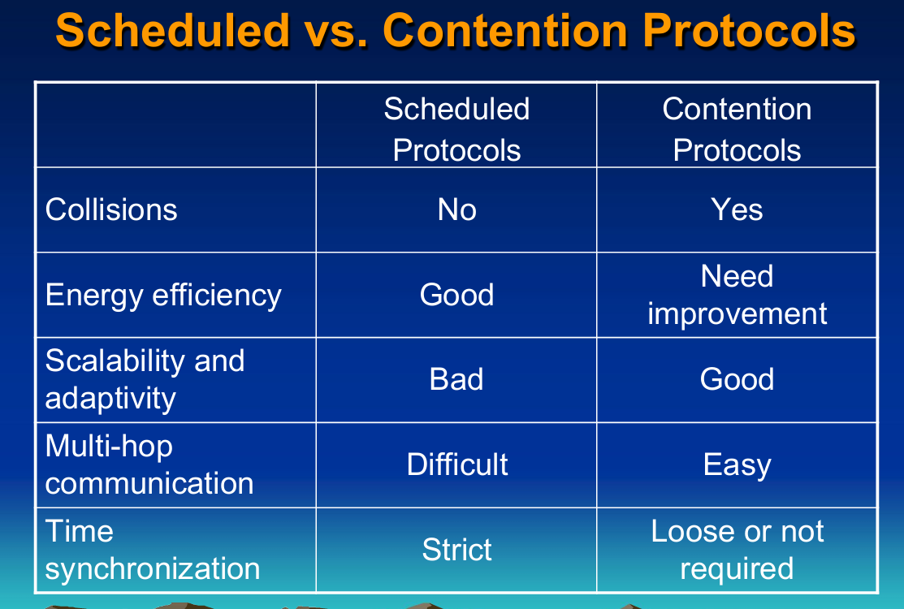

**OR,**

**Table**

| **Feature** | **Contention-Based Protocols** | **Schedule-Based Protocols** |
| --- | --- | --- |
| **Access Method** | Random access | Deterministic access |
| **Collision Handling** | Collisions likely, resolved using backoff | Collision-free due to scheduled slots |
| **Adaptability** | Highly adaptable to traffic changes | Less adaptable, requires rescheduling for changes |
| **Synchronization** | Not required | Required |
| **Energy Efficiency** | Lower due to collisions and idle listening | Higher due to scheduled transmissions |
| **Examples** | CSMA, B-MAC | TDMA, LEACH |
| **Scalability** | Generally scalable, but performance degrades with traffic | Can be less scalable, especially with dynamic changes |
| **Implementation Complexity** | Simpler to implement | More complex due to synchronization needs |

**Write short note on IEEE 802.15.4.**

IEEE 802.15.4 is a standard for low-rate wireless personal area networks (LR-WPANs). It provides the foundation for various higher-level communication protocols, such as Zigbee, WirelessHART, and Thread. The standard is designed to offer simplicity, low cost, and low power consumption, making it ideal for wireless sensor networks, home automation, and industrial control systems.

**Key Features**:

1. **Low Data Rates**:
   * Supports data rates of 20, 40, 100, 250, 500, and 1000 kbps, which are sufficient for applications requiring simple, low-speed data transmission.
2. **Low Power Consumption**:
   * Optimized for battery-powered devices, allowing for extended operation on small batteries.
3. **Short-Range Communication**:
   * Typically operates over short distances (10-100 meters), suitable for personal area networks.
4. **Simple Network Topologies**:
   * Supports star, peer-to-peer, and cluster tree topologies, enabling flexibility in network design.
5. **Frequency Bands**:
   * Operates in multiple ISM bands, including 868 MHz (Europe), 915 MHz (North America), and 2.4 GHz (worldwide).
6. **Robustness and Reliability**:
   * Utilizes techniques like Direct Sequence Spread Spectrum (DSSS) to minimize interference and enhance communication reliability.

**Components**:

1. **Physical Layer (PHY)**:
   * Defines the radio frequency (RF) transceiver specifications, modulation, and data transmission methods.
   * Employs DSSS to improve signal robustness and reduce interference.
2. **Medium Access Control Layer (MAC)**:
   * Manages access to the radio channel, including mechanisms for collision avoidance and resolution.
   * Provides support for both beacon-enabled and non-beacon-enabled modes, allowing for flexible network operation.

**Applications**:

1. **Home Automation**:
   * Used in smart home devices for lighting, heating, and security systems.
2. **Industrial Control**:
   * Employed in industrial automation and control systems for monitoring and management tasks.
3. **Healthcare**:
   * Facilitates wireless medical monitoring devices and wearable health sensors.
4. **Consumer Electronics**:
   * Integrated into various consumer gadgets like remote controls, gaming devices, and more.
5. **Agriculture**:
   * Used in precision farming for monitoring environmental conditions and managing resources efficiently.

**Advantages**:

1. **Cost-Effective**:
   * Low implementation and operational costs make it accessible for a wide range of applications.
2. **Flexibility**:
   * Supports multiple network topologies and frequency bands, making it adaptable to various use cases.
3. **Scalability**:
   * Can be scaled from small to large networks without significant changes in the infrastructure.
4. **Interoperability**:
   * Provides a common standard for different devices to communicate seamlessly, fostering interoperability.

**Group C:**

**LEACH protocol in details.** **Why the hierarchical routing protocol is needed in WSNs**

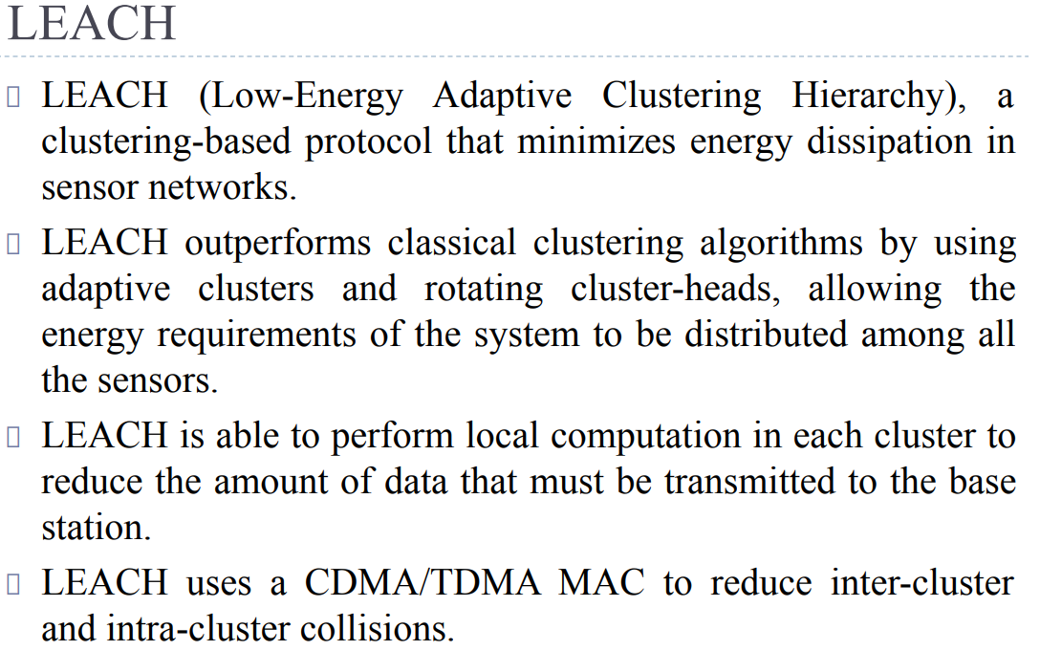

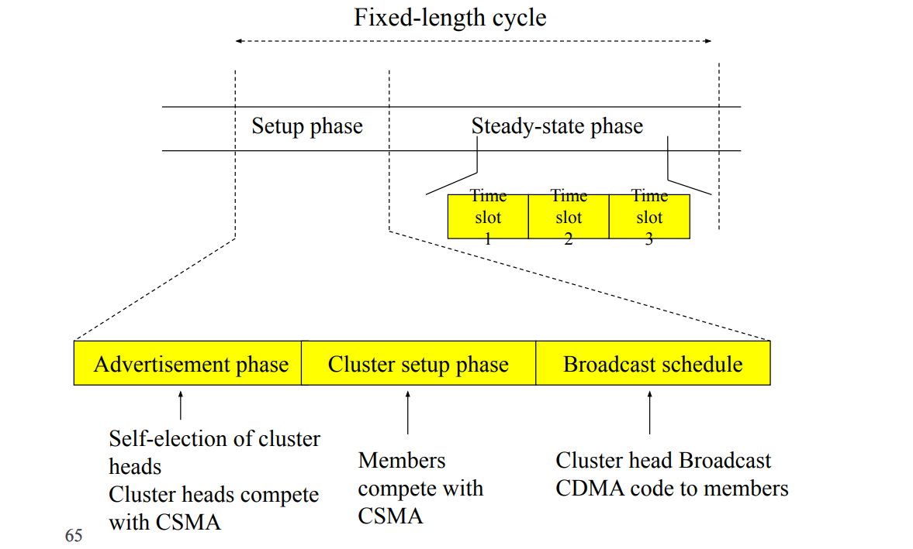

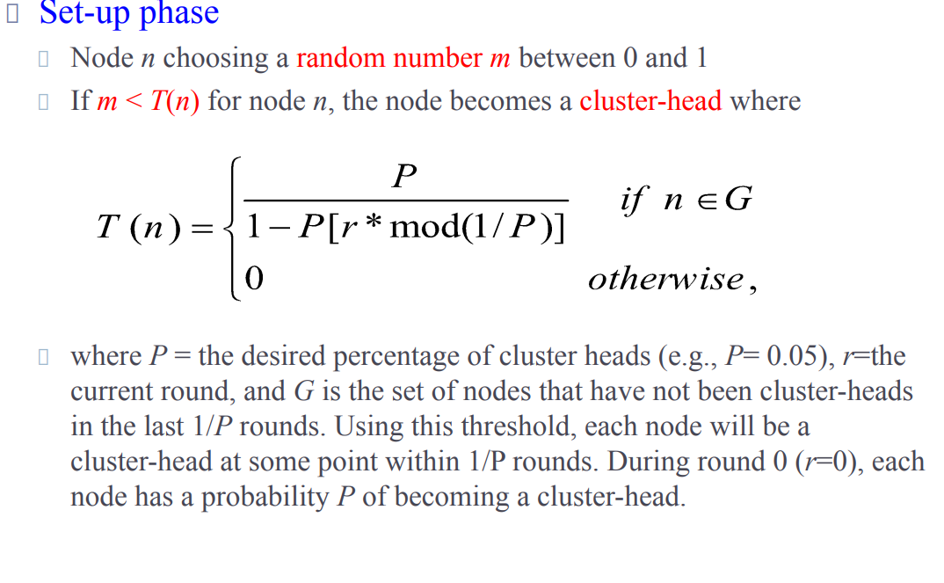

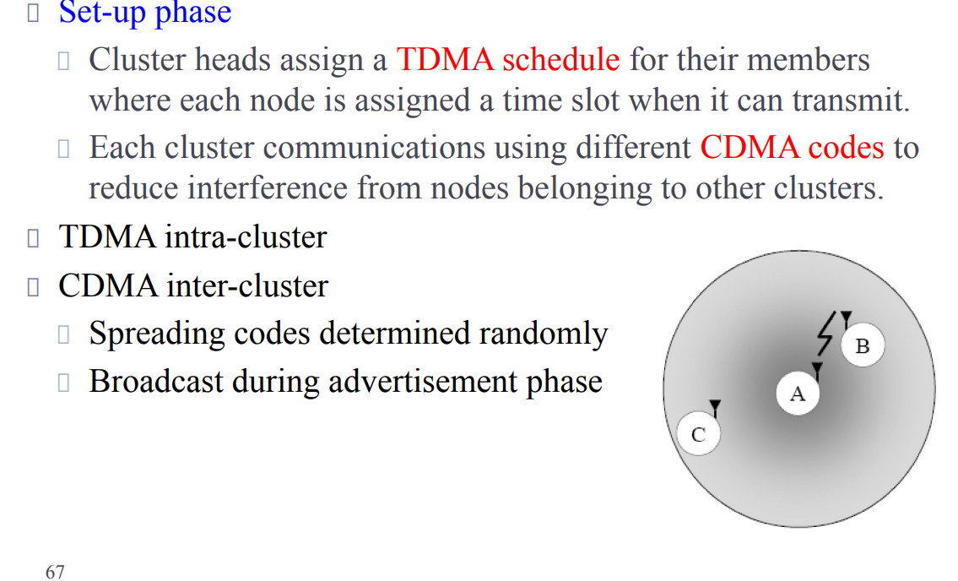

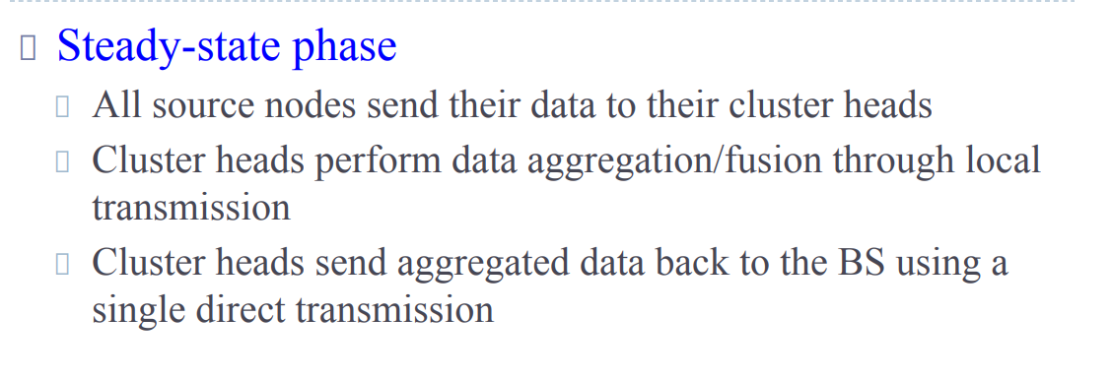

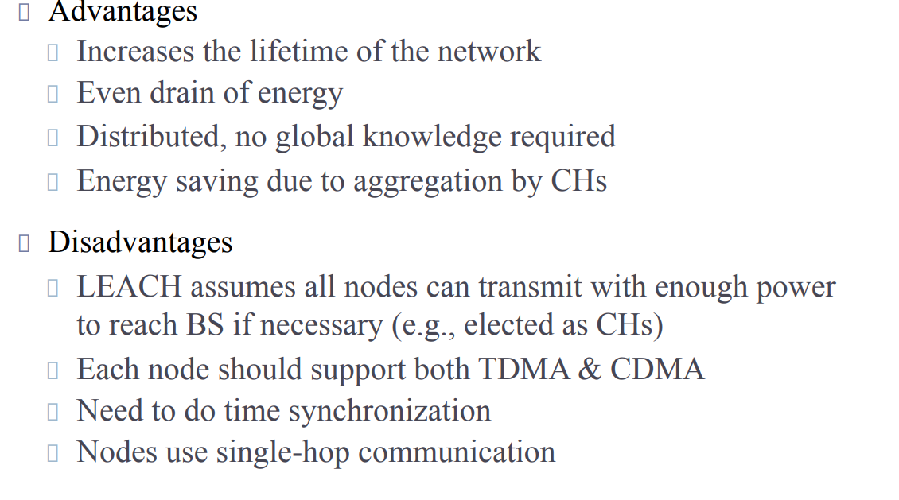

**\*\***

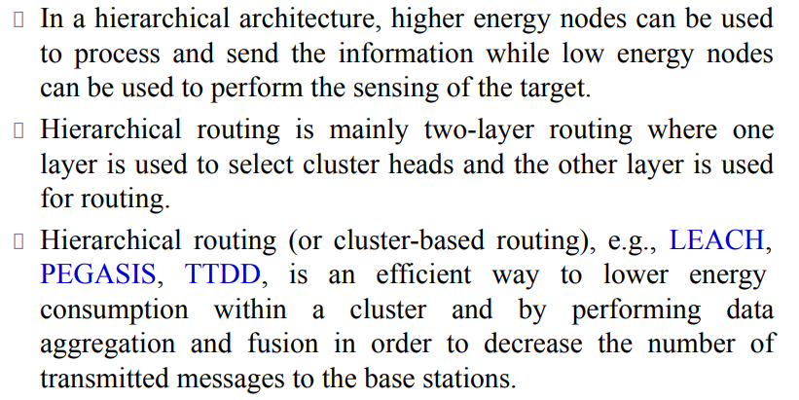

**Define flat routing in WSNs? Explain the working principle of the SPIN and DD routing protocols.**

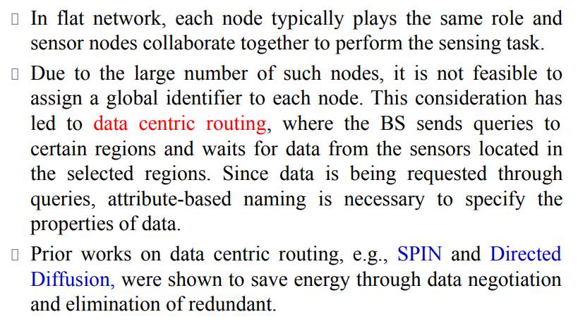

**\*\***

• **SPIN (Sensor Protocol for Information via Negotiation)**: SPIN is a data-centric routing protocol designed specifically for wireless sensor networks (WSNs). Its working principle revolves around minimizing communication overhead and conserving energy, which are critical factors in WSNs due to the limited power resources of sensor nodes.

* **Data-Centric Approach**: SPIN focuses on data rather than on individual nodes. It organizes data into packets called Data Description (DD) packets and Data packets.
* **Negotiation-based Communication**: SPIN uses a negotiation mechanism to exchange information about data. Nodes interested in specific data types broadcast requests, and nearby nodes with relevant data respond with Data Description packets.
* **Data Aggregation and In-network Processing**: SPIN supports in-network processing and aggregation, where nodes can combine data before forwarding it to the sink node. This reduces redundant transmissions and conserves energy.
* **Low Energy Consumption**: By minimizing unnecessary transmissions and processing data locally, SPIN reduces energy consumption in the network, prolonging the network's lifetime.

• **DD (Directed Diffusion)**: DD is another data-centric routing protocol commonly used in WSNs. It focuses on efficiently delivering data from source nodes to sink nodes while adapting to changing network conditions.

* **Interest-Based Communication**: In DD, nodes express interest in specific types of data by sending interest messages to their neighbors. These interests propagate through the network.
* **Gradient-Based Data Forwarding**: DD uses gradients to establish paths from source nodes to sink nodes. When a node receives an interest message, it creates a gradient towards the source and forwards data along the steepest gradient towards the sink.
* **Data Caching and Reinforcement**: DD employs data caching at intermediate nodes. If a node receives multiple interests for the same data, it caches the data and reinforces the corresponding gradient, making future data requests more efficient.
* **Adaptive Routing**: DD adapts to changing network conditions by adjusting gradients dynamically. If a path becomes congested or unreliable, nodes can reroute data along alternative paths to ensure delivery.

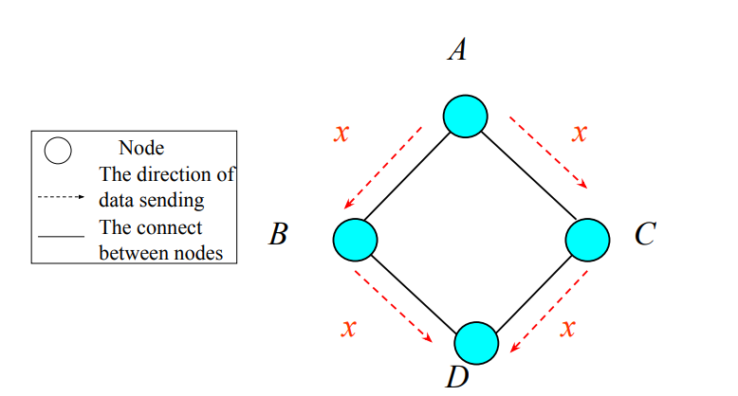

**Draw the architecture of a sensor node and discuss various components of it.** **Draw the architecture of a sensor node and discuss various components of it.**

#### Components:

1. **Sensing Unit:**
   * **Sensors:** Measure physical parameters such as temperature, humidity, light, etc.
   * **ADC (Analog-to-Digital Converter):** Converts analog sensor signals into digital data for processing.
2. **Processing Unit:**
   * **Microcontroller:** Executes the embedded software, processes sensor data, and controls node operations.
   * **Memory:**
     + **RAM (Random Access Memory):** Temporary storage for data and computations.
     + **Flash Memory:** Permanent storage for the program code and long-term data.
3. **Communication Unit:**
   * **Transceiver:** Manages wireless communication with other nodes and base stations, typically using protocols like Zigbee or Bluetooth.
   * **Antenna:** Facilitates the transmission and reception of radio signals.
4. **Power Unit:**
   * **Battery:** Primary power source for the node.
   * **Energy Harvesting Modules (optional):** Additional power from environmental sources like solar energy to extend battery life.
   * Manages power distribution, ensuring efficient energy use and extending battery life by switching off inactive components.
5. **Optional Components:**
   * **GPS:** Provides location data for applications requiring precise positioning.
   * **Mobilizer:** Allows the node to move or be repositioned, useful in dynamic environments.

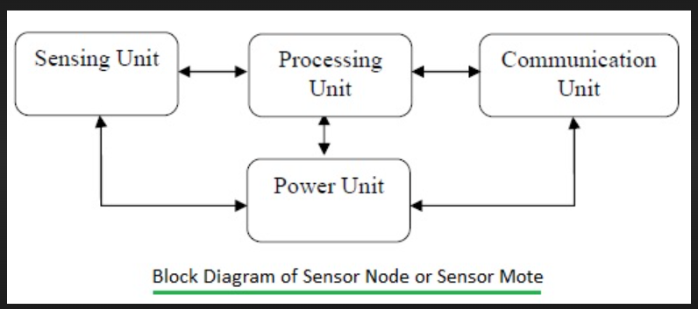

**2.**

**Attributes of MAC Protocol in WSNs**

1. **Energy Efficiency:**
   * Minimizing energy consumption is critical due to the limited battery life of sensor nodes.
   * Techniques such as duty cycling (periodically turning the radio on and off) and efficient sleep schedules are used to save power.
2. **Scalability:**
   * The MAC protocol should handle a large number of sensor nodes without significant performance degradation.
   * It should be able to maintain efficiency as the network grows in size.
3. **Latency:**
   * Reducing the time delay for data transmission is essential, especially for time-sensitive applications.
   * Protocols must balance energy efficiency with acceptable levels of latency.
4. **Throughput:**
   * Maximizing the amount of data successfully transmitted in a given time frame is important for data-intensive applications.
   * The protocol should handle high data rates effectively.
5. **Fairness:**
   * Ensuring that all nodes get a fair opportunity to transmit their data.
   * Preventing any single node from dominating the communication channel.
6. **Robustness:**
   * The protocol should be resilient to node failures and changing network conditions.
   * It should maintain network performance despite the dynamic nature of WSNs.
7. **Flexibility:**
   * The MAC protocol should adapt to different network requirements and environmental conditions.
   * This includes adjusting to varying traffic patterns and node densities.

**Causes of Energy Consumption in the MAC Layer of WSNs**

1. **Idle Listening:**
   * Nodes consume energy while listening for potential communication even when there is no data to receive.
   * Idle listening is one of the primary sources of energy waste.
2. **Overhearing:**
   * Nodes consume energy by receiving and decoding packets that are intended for other nodes.
   * This unnecessary processing leads to additional energy consumption.
3. **Collision:**
   * When multiple nodes transmit simultaneously, their signals can collide, leading to corrupted data.
   * Retransmitting the collided packets consumes extra energy.
4. **Protocol Overhead:**
   * Control packets (e.g., RTS/CTS in CSMA/CA) are necessary for managing communication but add overhead.
   * The transmission and reception of these control packets contribute to energy consumption.
5. **Retransmissions:**
   * Packet loss due to collisions or poor link quality necessitates retransmissions.
   * Each retransmission increases the energy expenditure of the nodes.
6. **Synchronization:**
   * Maintaining time synchronization among nodes (for protocols that require synchronized communication) requires periodic exchange of synchronization messages.
   * This exchange consumes energy.
7. **Packet Overhead:**
   * Including additional headers and metadata for MAC protocol functionalities increases packet size.
   * Larger packets require more energy for transmission and reception.

### 3.

### Factors Influencing Routing Protocols in WSNs

Routing protocols in Wireless Sensor Networks (WSNs) are crucial for efficient data transmission from sensor nodes to the base station or sink. Various factors influence the design and performance of these routing protocols:

1. **Energy Efficiency:**
   * **Battery Life:** Sensor nodes are typically battery-powered, so energy efficiency is critical to prolong network lifetime.
   * **Energy Consumption:** Routing protocols must minimize energy consumption during data transmission and reception.
2. **Scalability:**
   * **Network Size:** The protocol should support a large number of sensor nodes without significant performance degradation.
   * **Node Density:** It should efficiently handle varying node densities within the network.
3. **Data Aggregation:**
   * **Redundancy Elimination:** Combining data from different nodes to eliminate redundancy and reduce the number of transmissions.
   * **In-Network Processing:** Performing data aggregation and processing within the network to save energy and reduce communication overhead.
4. **Latency:**
   * **Time Sensitivity:** Some applications require timely data delivery, so routing protocols must ensure low latency.
   * **Hop Count:** The number of hops data packets take to reach the sink affects latency and energy consumption.
5. **Reliability:**
   * **Packet Delivery Ratio:** The protocol should ensure a high ratio of successfully delivered packets.
   * **Fault Tolerance:** Ability to handle node failures and maintain network functionality.
6. **Topology Control:**
   * **Network Dynamics:** WSNs often have dynamic topologies due to node mobility, addition, or failure.
   * **Self-Organization:** Protocols should enable the network to self-organize and adapt to topology changes.
7. **Load Balancing:**
   * **Traffic Distribution:** Distributing traffic evenly across the network to prevent overloading certain nodes.
   * **Energy Balancing:** Ensuring that no single node depletes its energy resources faster than others.
8. **Data Delivery Model:**
   * **Event-Driven:** Data is transmitted only when an event occurs.
   * **Periodic:** Data is transmitted at regular intervals.
   * **Query-Driven:** Data is transmitted in response to specific queries from the base station.
9. **Security:**
   * **Data Integrity and Confidentiality:** Ensuring that data is not tampered with and is secure during transmission.
   * **Authentication:** Verifying the identity of nodes to prevent unauthorized access.
10. **Node Heterogeneity:**
    * **Resource Diversity:** Nodes may have different capabilities in terms of energy, computation power, and communication range.
    * **Role Differentiation:** Some nodes might act as cluster heads or aggregators, necessitating different routing considerations.
11. **Environmental Factors:**
    * **Physical Barriers:** Obstacles in the environment can affect signal propagation and connectivity.
    * **Interference:** Electromagnetic interference from other devices can impact communication quality.

### 6.

### Architecture of WSNs for Detecting Forest Fire

#### 1. Sensor Nodes

* **Sensors:**
  + Temperature sensors
  + Humidity sensors
  + Smoke sensors
  + CO2 sensors
* **Components:**
  + Microcontroller (processing unit)
  + Power unit (battery, possibly with solar energy harvesting)
  + Communication unit (wireless transceiver)
  + Memory (RAM, flash storage)

#### 2. Cluster Heads

* **Roles:**
  + Aggregating data from sensor nodes within their cluster
  + Performing preliminary data processing
  + Communicating aggregated data to the base station
* **Components:**
  + Enhanced processing unit
  + Larger power unit
  + High-power transceiver for long-range communication

#### 3. Base Station

* **Roles:**
  + Collecting data from cluster heads
  + Performing advanced data analysis
  + Acting as a gateway to external networks (e.g., the internet)
* **Components:**
  + High-performance computing unit
  + Large power supply (possibly solar-powered)
  + High-range communication system (satellite or cellular)

#### 4. Communication Network

* **Intra-Cluster Communication:**
  + Sensor nodes communicate with their respective cluster head using short-range wireless communication (e.g., Zigbee, Bluetooth)
* **Inter-Cluster Communication:**
  + Cluster heads communicate with the base station using long-range communication protocols (e.g., LoRa, cellular)

#### 5. Data Aggregation and Processing

* **Local Processing:**
  + Sensor nodes and cluster heads perform initial data processing to reduce data redundancy
* **Centralized Processing:**
  + The base station performs comprehensive data analysis and interpretation

### Diagram of the Architecture

plaintext

Copy code

-------------------

| Base Station |

| (Data Analysis |

| and Gateway) |

-------------------

|

|

-------------------

| Long-range |

| Communication |

-------------------

|

|

-------------------------------------

| |

------------------- -------------------

| Cluster Head | | Cluster Head |

| (Data Aggregation)| | (Data Aggregation)|

| and Relay Node | | and Relay Node |

------------------- -------------------

| |

------------------- -------------------

| Sensor Nodes | | Sensor Nodes |

| (Temperature, | | (Temperature, |

| Humidity, Smoke) | | Humidity, Smoke) |

------------------- -------------------

### Explanation of Model Usefulness for Forest Fire Detection

1. **Early Detection:**
   * Sensor nodes equipped with temperature, humidity, smoke, and CO2 sensors can detect anomalies indicative of a fire at an early stage.
2. **Energy Efficiency:**
   * The hierarchical structure (sensor nodes to cluster heads to base station) ensures efficient energy use. Sensor nodes communicate only with nearby cluster heads, conserving their limited battery life.
3. **Data Aggregation:**
   * Cluster heads aggregate data from multiple sensor nodes, reducing the amount of redundant data transmitted to the base station. This aggregation reduces communication overhead and energy consumption.
4. **Scalability:**
   * The architecture can easily scale by adding more sensor nodes and cluster heads, allowing coverage of large forest areas without compromising performance.
5. **Reliability:**
   * Redundant sensor nodes and overlapping communication ranges ensure reliable data collection even if some nodes fail or get damaged.
6. **Real-time Monitoring:**
   * Continuous data transmission from sensor nodes to the base station allows for real-time monitoring and prompt response to potential fire incidents.
7. **Alert System Integration:**
   * The base station can be integrated with alert systems (e.g., SMS, email, sirens) to notify authorities and firefighters immediately upon detecting signs of a forest fire.
8. **Adaptability:**
   * The system can be adapted to different environmental conditions and updated with new sensors or technologies as needed.